Polynomial Texture Maps

CS 766 Homework 5

Alex Mohr
Fall 2001

Abstract:
This work implements Polynomial Texture Maps as presented by Malzbender et al. at SIGGRAPH 2001. Polynomial Texture Maps (PTMs) are a space and time efficient method for encoding an object’s diffuse lighting response as the light position varies with respect to the surface. A traditional texture map encodes a different color C for each point (u,v) on a surface. In contrast, a PTM encodes a set of coefficients Cf for each point on a surface. These coefficients are parameters to a polynomial model that approximates the surface point’s color change as the lighting position changes. The object is sampled from a number of different lighting directions, and coefficients are obtained by a least-squares fit of the model to the data. During rendering, the pixel-processing hardware of modern graphics processors is used to evaluate the polynomial model very quickly. Because each point on a surface can vary with the lighting direction, PTMs can capture interesting surface reflectance properties that normal texture maps cannot. These include approximately correct diffuse lighting for small-scale features and global effects like self-shadowing.

- Introduction
Texture mapping has long been used in computer graphics to enhance the realism of rendered images. Texture mapping works by pasting pictures (the texture maps) onto polygons so that when they are rendered, the polygons contain much more detail than can be provided by simple flat or smooth shading. Texture mapping is used extensively in interactive applications, like computer games. This is often because the graphics hardware can only draw a relatively small number of polygons at interactive rates. In order to make the rendered images look more realistic, texture maps are applied to the coarse geometry. Texture maps are often created in an attempt to “fool the eye”. For example, texture artists often paint lighting effects into their textures, and this effect is often convincing. For example, a character in a video game may only have 5-10 polygons in his face. This raw geometry is not enough to create an acceptable face representation. To make the face appear more realistic, texture artists will apply texture maps that simulate the look of facial features under typical lighting conditions. An example of such a texture map is shown in Figure 1. The false shadows and other lighting effects are physically drawn on the texture.


Figure 1: A texture map for a popular game. Notice how lighting response is directly drawn into the texture. The lips, nose and hair are most noticeable.

More recently, the field of image-based modeling and rendering has begun to merge with traditional rendering. Many image-based techniques are finding application in interactive and offline rendering. Polynomial texture maps is one technique like this. Traditional texture maps are static and therefore do not model surface reflectance well. In contrast, polynomial texture maps change appearance as lighting or other environmental conditions change, allowing for a much better surface reflectance approximation.
- Sampling Reflectance
Polynomial texture maps use data fitting techniques to model surface reflectance. Therefore, a number of sample images must be provided for the technique to work. The implementation of PTMs presented here has been tested with a set of real data sampled using a digital camera and several sets of synthetic data, composed and rendered in Maya. Only one set of real data is shown because the equipment to build a proper rig could not be obtained in time for this writing. With a proper rig, PTM capture can be made fully automatic.
The photographic sampling process for PTMs is very similar to the sampling process in photometric stereo. In the ideal case, a camera is fixed directly at the object to be sampled, and not moved at all during sampling. This eliminates all camera calibration and setup problems. During capture, a light source is placed in various locations around the object, typically a fixed distance away. For each light position, a photograph of the object is obtained. Because accurate light positions are required, lights are often placed on a hemisphere over the object.
As mentioned previously, the equipment to build a proper PTM capture device was not obtained in time for this report, however a manual set of data was still captured. This was accomplished by placing the subject (some Gardetto’s snacks) on a turntable, fixing a camera to look directly at the subject, and setting up a light that could be positioned on a quarter-circle arc, always facing the subject. The PTM data was captured by rotating the turntable and moving the light along the quarter circle arc to obtain 40 samples distributed over the hemisphere. The distribution of sample points and a sample image is shown in Figure 2.

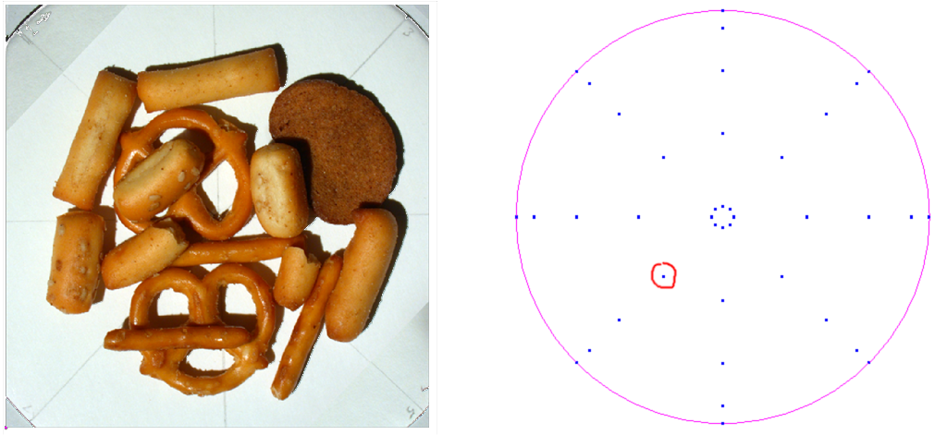Figure 2: The circle on the right show the placement of the light for the 40 samples of this real data set. The red circle indicates the sampling position that the image on the left corresponds to.

This method of capture has a significant drawback. Since the turntable containing the subject was turned relative to the camera during capture, the images had to be registered after capture was complete. This was painstakingly done by hand and the results are not perfect.
Generating synthetic sample data is considerably less error-prone, but less interesting from a Computer Vision standpoint. However, the synthetic data has some advantages in that important test cases can quickly, easily, and exactly be created. Creating scenes in Maya and rendering them with a light source at different positions generated the synthetic data used in our implementation.
- Fitting and Reconstruction
After a sufficient sampling of data is collected, the data is analyzed and a biquadratic polynomial is fit to each pixel in the texture map that encodes its response under the varying lighting directions.
The objects modeled here are assumed to be perfectly Lambertian. That is, the surface reflectance at each pixel depends only on the intrinsic material color of the object, the surface normal, and the light direction. This precludes any sort of view-dependent effects like specular highlights. Polynomial texture maps are not strictly limited to diffuse objects—they can be generalized to handle view dependent effects like specularity by evaluating more than one PTM, but this report is limited to the purely diffuse case.
A key observation made in the original PTM paper is that the chrominance of a pixel remains fairly constant as the lighting direction changes—the luminance is what varies. Taking advantage of this, we can store the chrominance per pixel in a traditional texture map, and then model the luminance as a scalar-valued function of the light position per pixel. Then to render an image, the luminance model is evaluated for each pixel, and then combined with the chrominance value to produce the final output color.
The PTM paper asserts that luminance on a given pixel varies smoothly with lighting direction in nearly all cases. Therefore, they advocate fitting a biquadratic function to the luminance data. This works well in their examples, and Figure 3 shows an example of PTM reconstruction based on this idea.
Unfortunately, many important details of the method are left out of the paper. For example, the PTM approach requires that an RGB chrominance image be factored from the set of source images to be used when reconstructing a final image, but their method for doing this factoring is not stated. Further, their method for factoring the luminance values for each pixel in each image for use in fitting the biquadratic is not stated.
This work notes a small generalization of the factoring and fitting methods and explores the results obtained with a few different methods.
- Results
The PTM implementation in the paper factors images into luminance (L) and chrominance (cR, cG, cB) such that the original pixel color can be reconstructed by (LcR, LcB, LcG). This representation is redundant but is used because it computes quickly in current graphics hardware. The paper mentions that only one RGB image is stored with each PTM but gives no indication of how they decide what colors should be in that RGB image and also no indication of how chrominance and luminance are factored for individual images.
We have found that the method of factorization is critically important to the success of this technique. For example, Figure 3 shows from left to right two different reconstructions using two different factoring methods followed by the original input image. The approximations clearly improve in quality from left to right.
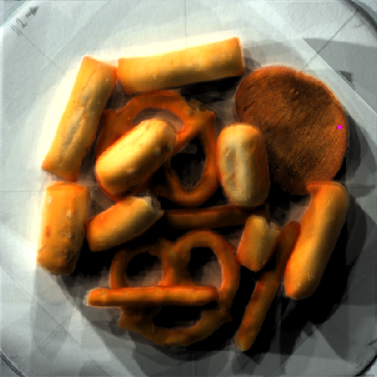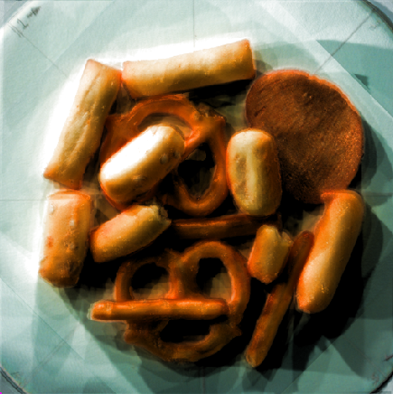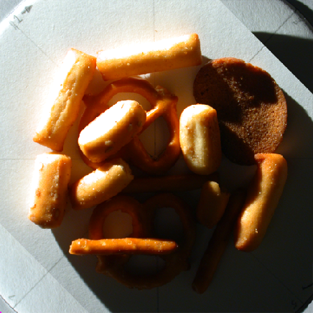
Figure 3: The far right image is a source photograph. On the far left is a PTM reconstruction of the far right image using a simple luminance/chrominance factorization scheme. Notice how the brightest spots in the far right image are only reproduced as dingy yellow using this factoring scheme. In the middle is a PTM reconstruction of the same image using our factoring scheme. Notice that the bright highlights are more faithfully preserved.

A very simple method to factor luminance and chrominance works as follows: Record the length of each color “vector” in RGB space as luminance, then normalize the vector and store this as chrominance. To reconstruct the original, simply multiply the normalized color by the luminance value. This works okay, but has a significant drawback—it constrains color reconstructions to lie on a single ray from the color black (0,0,0) through the color and out of the color cube. This is a problem because many pixels in the image wash out as pure white when their signals clip, but this reconstruction can only take pure gray values into pure white. Figure 4 shows that for real world data, pixel values follow a curve from near-black to near-white, not any straight line at all. Under this and similar factoring schemes the snacks on the far left of Figure 3 only approximate the washed out areas in the original image with a dull yellow color.
A better factoring scheme draws on a simple generalization of the luminance/chrominance factoring idea. The idea is that it is unimportant whether we actually factor luminance and chrominance just as long as we separate those color components that are mostly constant with respect to lighting changes and model those that vary as a single scalar value. To ensure a good biquadratic fit to this invented “luminance” we must ensure that it changes smoothly as the lighting condition changes. Finally, to ensure rapid computation, the final color of a pixel given the two factors must be computed simply.
Our scheme works as follows. When factoring the color C, we first determine what side of the plane (1,1,1,1/2) in RGB color space it is on. This plane passes through the middle-gray point and is perpendicular to the vector <1,1,1>. We call the side of the plane that includes the color white <1,1,1> the “light” side, and the other side that contains the color black <0,0,0> the “dark” side. After the color’s plane side is determined, it is converted into a chrominance value by mapping it onto the (1,1,1,1/2) plane. For the light side of the plane, the point is mapped by extending the ray from <1,1,1> through the color C until it hits the plane. For the dark side of the plane, the point is mapped by extending the ray from <0,0,0> through the color until it hits the plane. Luminance is then stored as a scalar value that scales the color vector back to its original color. Plane side is encoded as the sign of this parameter, and the parameters are selected such that the dark side’s parameter values are nearly -1 at <0,0,0> and nearly 0 at <0.5,0.5,0.5>. Similarly, the light side’s values go from nearly 0 at <0.5,0.5,0.5> to nearly 1 at <1,1,1>. This eliminates severe jump-discontinuities from the luminance space helping to ensure a good fit. This method was attempted after viewing several graphs of the colors obtained for a given pixel on the color cube. Figure 4 shows an example of this plot where color values curve from the dark side to the light side (depending on the optimism of the reader) rather than following straight lines. We note that there is a potential corner discontinuity introduced with our method but this has not affected us in practice. Figures 3b and 3c show a comparison of this method and the more straightforward method.

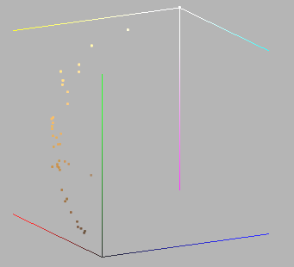
Figure 4: A plot of a single pixel’s color values for every image in a PTM data set. Notice how the colors follow a curve from nearly black to nearly white instead of tracing any straight line path through the cube.

Finally, we present our method for determining the factored chrominance map and the luminance values used to do the model fitting. Both of these issues are not addressed in the paper. We determine the full chrominance map in a straightforward manner. We simply project colors onto the dividing plane as mentioned above for each sample image. Then we compute the total chrominance map by averaging these pixel values together for every normalized sample image. When fitting the biquadratic functions to luminance, we could simply use the factored luminance values obtained in the first image normalization step. However, this is sub optimal because the chrominance image we will use to reconstruct a view of the scene is now an average of all the chrominance maps—not the one corresponding to the factored luminance. Instead we have a procedure to “re-fit” the luminance values. We simply compute for each pixel in each image the luminance value that takes the factored chrominance image pixel as close to the original pixel as possible. This produces subtle but noticeably sharper results as shown in Figure 5.
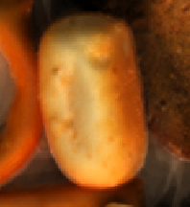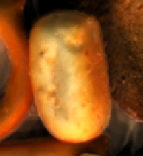
Figure 5: Enhanced sharpness from our refitting process. The image on the left shows a PTM reconstruction that used luminance values from each source image’s factoring to compute the luminance model. On the right is a PTM reconstruction that used our refitting technique with the averaged chrominance map to supply luminance values for fitting the model. Notice the increased color contrast and sharpness in the image on the right.

- Conclusion
We have presented an implementation of polynomial texture maps—a novel method for efficiently encoding surface reflectance dependent on lighting direction. This work has limited its scope to purely Lambertian PTMs but the method can be generalized beyond that. We have presented a small generalization of and a new method for luminance / chrominance factoring, and we have demonstrated results on a real datasets. Even though PTMs produce good results in many cases, they are limited. In particular, because we are fitting smooth surfaces to lighting response, legitimate high frequencies cannot be captured. These effects manifest themselves where sharp shadow boundaries and highly specular surfaces occur, and have the effect of muting the shadows and specularities.

